





**Audit of Home-Start Board Minutes Network Report**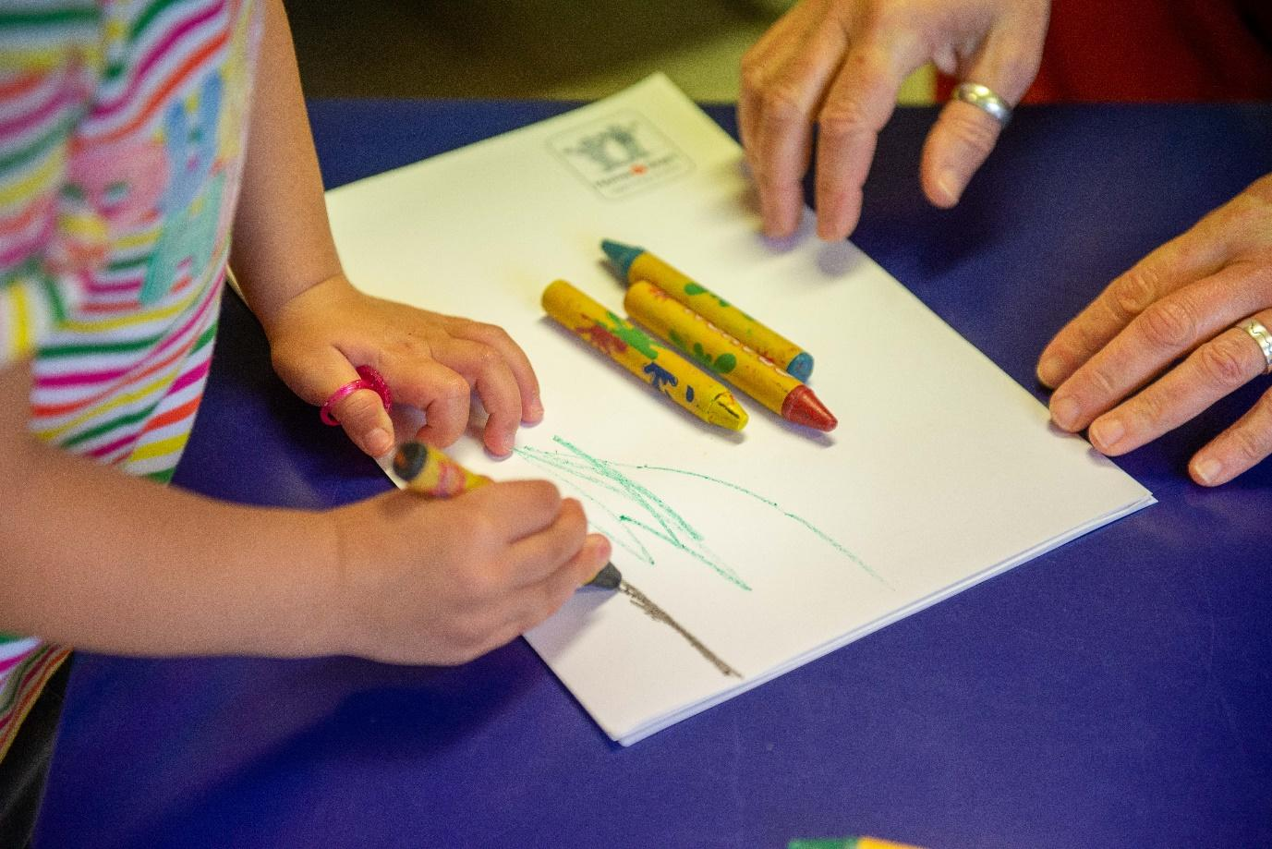



| **Title** | **Home-Start Digital/ Social Media Policy** | **Date: 02/07/24** |
| --- | --- | --- |
| **Author** | [**Enjoy Digital**](https://enjoydigital.uk/)**- Consultancy (with HSUK)** |  |
| **Approver** | **Director of Network Impact** |  |
| **Owner** | **Head of Quality and Safeguarding** | **02/07/24** |
| **Published** | **@Home** | **02/07/24** |
| **Review Frequency** | **Three years or following significant changes in legislation** |  |
| **Next publication date** |  | **02/07/27** |

This is a controlled document. It should not be altered in any way without the express permission of the policy owner or their representative. On receipt of a new version, please destroy all previous versions. If you are reading a printed copy of this document, you should check @Home Intranet website to ensure that you are using the most current version.

**1. Introduction**

**1.1 Policy Statement**

Home-Start South Warwickshire (HSSW) recognises the importance of social media as a powerful tool for engaging with our stakeholders, delivery of services, raising awareness, and advancing our mission. This policy sets out guidelines and best practices for the responsible and effective use of social media/digital platforms by our charity.

**1.2 Purpose/Scope**

The purpose of this policy is to:

* Define the roles and responsibilities of individuals associated with HSSW in using social media and digital platforms.
* Ensure that our charity's social media presence aligns with our values, mission, and [ethical principles](https://www.ncvo.org.uk/help-and-guidance/running-a-charity/charity-ethical-principles/).
* Ensure that our charity’s use of digital platforms for service delivery is planned, managed, and aligns with our values, mission, and ethical principles.
* Promote transparency, accountability, and consistency in our social media communications.
* Mitigate potential risks associated with the use of social media and digital platforms.

This policy applies to all employees, volunteers, trustees, and any other individuals representing HSSW on social media platforms or when using digital delivery methods. It covers the use of social media for both personal and organisational purposes. This policy should be used in accordance with the Home-Start [Digital/Online Audit Tool](https://at.home-start.org.uk/Interact/Pages/Content/Document.aspx?id=9556&SearchId=0) guidance which is available on @home.

**2. Guidelines for Social Media Use**

**2.1 How HSSW will use social media**

HSSW uses social media to achieve the following objectives:

* + Raise awareness about our charity's mission and activities.
  + Engage with stakeholders, including beneficiaries, donors, and the general public.
  + Deliver services through digital platforms where appropriate.
  + Promote transparency and share updates about our work.

**Platforms:**

HSSW uses the following digital/social media platforms – Facebook, Instagram, Linked In, Whatsapp.

The guidance to using these safely is listed here:

[Advice from main social media platforms](https://www.ncsc.gov.uk/guidance/social-media-how-to-use-it-safely)

[Home-Start risk assessment templates for platforms available here to adapt](https://at.home-start.org.uk/Interact/Pages/Content/Document.aspx?id=9556&SearchId=0)

**Private Community Groups and Discussion Forums:**

HSSW may create private community groups or host discussion forums to facilitate engagement with service users, staff, volunteers. These groups or forums will risk assessed and be moderated to ensure respectful, productive discussions. They must operate in line with other relevant Home-Start policies. Moderation guidelines are detailed in section 2.2.

[Suggested tools for auditing and risk assessing digital/online applications are detailed on this page on @Home.](https://at.home-start.org.uk/Interact/Pages/Content/Document.aspx?id=9556&SearchId=0)

**2.2 Moderation and Third-Party Content**

**Moderation of Third-Party Content:**

Third party content is content that was created by someone else. HSSW moderates third-party content to ensure it aligns with our values and does not violate Home-Start values and [brand positioning](https://homestartuk.brandstencil.com/resources/collection/320). Comments or posts that violate our guidelines will be removed and reported where appropriate (<https://saferinternet.org.uk/online-issue/reporting>).

**Comments and Responses:**

HSSW will respond to comments that are constructive, respectful, and relevant to the post.

Comments that require a response, such as enquiries or feedback, will be addressed promptly. Comments will be liked or reshared if they align with our mission and values.

**2.3 Oversight and Controls**

**Access and Security:**

Access to HSSW's social media accounts is restricted to authorised individuals only. These accounts are password-protected and monitored by designated staff/trustee.

HSSW will have in place a means of recovering accounts and accessing passwords should the designated staff/trustee be unavailable.

**Day-to-Day Content Posting:**

Authorised individuals, including staff and trustees, may post day-to-day content related to routine announcements of the charity’s work. This includes updates about our programs, events, and achievements. In order to avoid digital exclusion, provision should be made to provide information in a non-digital format.

**Additional Approval:**

High-profile announcements or addressing social media crises require additional approval by the Head of Operations.

**Content Review and Moderation:**

The Head of Operations will be responsible for reviewing and moderating content, managing how often this is done, and the process for reporting inappropriate content.

**Content Deletion:**

Authorised individuals may delete content in circumstances where it violates our values and mission or is no longer relevant.

**2.4 Rules and Compliance**

**Compliance with Laws and Codes of Conduct:**

All social media activities must comply with relevant laws and codes of conduct.

**Interactions with Children, Young People, and Adults at Risk of Harm:**

Everyone in Home-Start, regardless of their role, has a responsibility to protect children and be familiar with the local policy and procedure in reporting a concern. HSSW has specific guidelines to ensure safe and appropriate interactions with children and adults at risk. These guidelines are outlined in our Home-Start Safeguarding and Protecting Children and Safeguarding and Protecting Adults policies, alongside our Safeguarding and Protecting Children Code of Conduct.

**Skills and Knowledge:**

HSSW will provide training and guidance to individuals authorised to manage official charity social media accounts.

HSSW will provide all staff, trustees and volunteers with training/guidance to enable them to understand and adhere to the policy and procedures as it relates to them.

**2.5 Policy Enforcement and Incident Response**

**Policy Adherence:**

HSSW will regularly monitor compliance with this policy. Non-compliance may result in disciplinary actions. Failure to comply with this policy may result in disciplinary actions, including the removal of access to official social media accounts, for individuals associated with HSSW.

**Relationship to Other Policies:**

This policy interacts with our Safeguarding, GDPR/Confidentiality, Equality, Fairness and Diversity Policy, Whistleblowing and HR policies.

**Responding to Incidents:**

In the event of incidents or breaches of this policy, HSSW will take appropriate actions, including content amendment or deletion, involvement of senior staff, and reporting to the full trustee board/HSUK if necessary.

[Charity Commission - How to report a serious incident](https://www.gov.uk/guidance/how-to-report-a-serious-incident-in-your-charity)

[HSUK Reputational Issues Form](https://webforms.dizions.co.uk/home_start_uk_central_system/reputational-issues)

**Complaints and Abusive Messages:**

HSSW will respond professionally to complaints or criticism on social media. In case of abusive messages, we will provide support to trustees, staff, and volunteers who are subjects of online abuse.

**Social Media Crisis Management:**

HSSW has a communications plan in place for handling social media crises/reputational issues. This includes stopping scheduled posts and sharing content from third parties [insert where this can be found- see Home-Start template available].

**Reporting Serious Incidents:**

If necessary, HSSW will report serious incidents to the Commission, police, or other regulators in accordance with legal requirements.

Serious incidents that meet the criteria will be reported to Home-Start UK.

**Emergency Recovery Plan**

HSSW has an emergency recovery plan to refer to in the event of hacking [insert where this can be found- see Home-Start template available].

**2.6 Monitoring and Accountability**

**Oversight:**

The Head of Operations is responsible for overseeing and enforcing this social media policy, including managing access and addressing leavers.

**Review and Updates:**

This social media policy will be reviewed annually and updated as needed to reflect changes in social media platforms, technologies, or regulations.

**2.7 Personal Social Media Use: (for all trustee, staff and volunteers)**

**Engaging in personal social media activities:**

* Any comment post, even if accounts are locked/private should be considered public and can reflect on the charity. Always think “would I want to see this post quoted in a newspaper with my name and HSSW attached to it”?
* Any staff member, volunteer or trustee using social media, even in a personal capacity, to publicly criticise the charity, or commenting in a way that is offensive, or which goes against our values or policies especially those relating to equality, fairness and diversity, harassment and bullying, or safeguarding could face disciplinary actions.
* Staff members, volunteers or trustees should also avoid posts that criticise partners and funders.
* Individuals associated with HSSW should make it clear that their views are their own and do not necessarily represent the views of the charity.
* Never share confidential or sensitive information related to the charity, its beneficiaries, or other stakeholders.
* Be mindful of the potential impact of personal social media posts on the charity's reputation.
* Maintain confidentiality and boundaries by not engaging or befriending service users through personal social media platforms.
* Personal social media conduct must be in line with the Home-Start Safeguarding and Protecting Children Code of Conduct.
* Be aware that comments or posts can be taken out of context and shared with a wider audience than originally intended.

**Contact Information**

Any questions or concerns related to this social media policy should be addressed to the Head of Operations.

Below is a list of policies that are also relevant to this policy. You may find it helpful to refer to any of these additional documents when reading and using this policy.

* Confidentiality
* Data Protection/GDPR
* Equity, Equality, Diversity and Inclusion
* Safeguarding & Protecting Children
* Safeguarding and Protecting Children Code of Conduct
* Safeguarding & Protecting Adults
* Reporting Serious Incidents and reputational threats to HSUK
* Compliments, Concerns and Complaints
* Online Safety guidance
* Whistleblowing
* Local Employment Handbook (including Anti-harassment and bullying, and social media)

Additional sources of support and information

Fundraising Regular: [Information for fundraising](https://www.fundraisingregulator.org.uk/code)

Social media: Protecting what you publish guide (NCSC)

[Social media: How to use it safely](https://www.ncsc.gov.uk/guidance/social-media-how-to-use-it-safely) (NCSC)

Safer Internet: [Reporting harmful content](https://saferinternet.org.uk/report-harmful-content)

| **Version Number** | **Summary of Changes Made** | **Authorised By** | **Date Issued** |
| --- | --- | --- | --- |
| 0.1 | First Draft for consultation | Director of Network Impact | 01.02.24 |
| 1.0 | Minor changes in light of feedback (for wording/clarity).  Clearer references/links made to Safeguarding Policies. | Head of Quality and Safeguarding | 02.07.24 |